Worldwide Growth Found in Montana Soil: Comparing Climates
Name: Carey Berendsen
Affiliation: Montana State University Billings
Class: Capstone and Senior Thesis
Date: November 25, 2025
Abstract
This thesis maps out the locations of the origin of different trees and examines the local Montana environment where they are found. By doing this, it is possible to plot out the major climates and how they are different from the Montana climate. Working with the Yellowstone Arboretum, which has both local and international trees, we can observe the long-term differences among the different trees and their original regions. After gathering the latitude and longitudes as well as the details of the international trees within the arboretum, it is organized into a spreadsheet and turned into an attribute table. From here, different visuals were created to compare the climates where the trees are found and determine whether they are compatible with Montana. Information between the different nurseries helps show the features of the many trees. The different climates will also range from dry, tropical, continental, temperate, and polar using the Köppen climate classification. Both these ranges and the specific data points of the trees will be mapped onto a map that shows the differences in climate. From this, we can also see some of the factors that should be considered when arboreal species take on these trees, like aesthetics, pollination, invasive, endangered, and unhealthy or dead trees. Being able to map out the Yellowstone arboretums’ trees and compare their climates will give us the results of which climates have trees that do well in Montana and which ones do not, as well as which climates are not compatible with the Montana environment. These results are detrimental as they can help guide arboretums with their trees that they chose to plant and what to expect.
Introduction
Arboretums are a fantastic resource for exploring and preserving a variety of trees and different collections with their biodiversity and research accessibility. They act as a museum, displaying the different trees as they grow and how healthy they are. As a nationally accredited arboretum, the Yellowstone Arboretum in Billings, Montana, is an example of an arboretum with both local and international trees. Their range of collections includes gardens such as the bamboo collection and historical collections like the Lewis and Clark collection. Sometimes these trees are found in different climates, and when looking at them in Montana, we can see how the trees in their original home and local trees compare at the arboretum, and it can help explain how they will grow and if they will be healthy in that climate. Arboretums are also important as they can take care of international trees and help with the different factors that limit the trees in the wild. This is especially important as the climate is changing and trees can not adapt enough to fit their original climates without human help. This research will address two main questions involving the Yellowstone Arboretum and its ability to take care of trees, and the limiting factor is whether the climates are compatible or not. These questions are: which non native trees displayed in the Yellowstone Arboretum are least suited to a Montana climate? Conversely, which non native trees thrive in a Montana climate?
To answer these questions, the study follows a list of goals. First, find and inventory all the international trees that may have varying climates in the arboretum. Second, research and create portfolios for each tree, including what elements they need to survive, if they have any negative traits, and where they are from. The third step is organizing this information in a way that can help determine results. This will be done by creating visuals; there will be two maps, one showing the locations of the trees within the arboretum, where you can find their individual portfolios, and see what positive or negative factors they contribute to the Yellowstone Arboretum. The second map shows the region of their origins, as well as the Koppen climate specific to the origin. Then there are a variety of charts breaking down the origins of the trees, their different climates, and their individual transplanting factors. From here, the findings are analyzed, and patterns based on compatibility and individual tree factors were studied to see if there are any climates that work better in the Montana climate. These different levels of analysis, as well as visualization, are needed to be able to anticipate the effects of the different origins of different kinds of trees in Montana. From this point, arboretums will be able to troubleshoot these future issues with their different collections and take steps to help take care of them individually.
Literature Review
There is a lot of research connecting to both climate and climate change, based on the current global concerns of global warming. This research is specific to the effects of climate on trees for preservation purposes. Arboretums are crucial to highlight the findings in this research while also eliminating the other factors, like water supply or growing space (Department of the Interior, 2022). The climate affects a lot of conditions that influence the tree's health, like the overall temperature, the rainfall, the moisture in the soil, and other stressors (Mann, 2025). Using the USDA cold hardiness zone as well as the Koppen climate classification helps with a multi-perspective approach for classifying the trees (Barve et al, 2024, and Cui, Liang & Wang, 2021).
Plants have to adapt and change to match these drastically changing conditions or change where they are growing (Solomon, 1997). This migration can be seen in African plants, which grow in higher areas in search of cooler temperatures (Haimerl, 2025). While other trees show resilience to these massive global changes, like the huge trees seen in the Amazon, most trees will not react this way due to their differences in size (Watts, 2025). This shows that different levels of trees can handle differences in the changing climate, and that other trees can survive but need to change locations. Some trees also need extra monitored care that arboretums can provide.
Similar to zoos that protect wild and endangered animals and are able to help preserve the population, arboretums help with trees and will play a heavier role in providing care and preserving species at risk due to climate change. However, not every arboreum is equipped to handle every type of tree, mainly due to changes from their origin to the new arboretum location. The arboretums are not only important but necessary, as it is predicted that 1 of every 3 species will eventually go extinct without intervention (Opgenhaffen, 2024). So even in Montana, the arboretum's goal is to help conserve and preserve the health of the trees. The Yellowstone Arboretum is a platform that is able to water its trees in times of drought, as well as prune and care for trees that are at a health risk (S. Meyers, personal communication, summer 2025). A great first step is to see which climates are similar to Montana’s and which trees can adapt and thrive in a continental climate area like Montana (Weatherspark). Specific trees like the Siberian pea shrub or Russian sage have a wide range of climate adaptability, and come from an origin that is compatible with Montana. However, on the other end of the spectrum, tropical trees of any variety will not be compatible with the large change in temperatures.
Data Collection and Methods
The Yellowstone Arboretum will be acting as a baseline and primary source for the trees and their reaction to the Montana climate. Research on the trees and their original climate provided key details about health risks, needs, information about their different geographic locations, and the range of climates that the trees can handle. The USDA Cold Hardiness zones and Koppen climate classifications were found for each tree and mapped out in both the arboretum and across the world.
Sampling included going to the arboretum in person and identifying the many trees there. There is a list compiled from the succession records of which trees the arboretum has that were researched, and from that, a list of international trees was compiled. Using this list at the arboretum to know which trees to identify was crucial. However, even with a list, there were still trees that were either dead or extras. Overall, there were 94 international tree portfolios gathered, but only 85 trees were mapped out, as some of the trees had died and have since been removed. The 85 trees each had their longitude and latitudes written down, as well as their names, notes about them, and the health conditions of unhealthy trees. The locations were tracked by using Gaia GPS, and it took 4 trips to find all the international trees, with each trip being about 3.5 to 4 hours.
Mapping was next and took a while first; all of the data collected was put onto a spreadsheet, where the portfolios were finished. This would be turned into an attribute table, but was done on Excel for easier editing. All of the information was then moved to ArcGIS Pro to be refined. There were two maps made. The first one is directly related to the attribute table and the coordinates that were gathered. It is a map of the arboretum with the international trees, and they are color coordinated according to the transplant factors that can affect the arboretum and its decisions regarding the trees. The second map breaks down one of the attribute sections, which is their origin locations, and maps out where they are in the world.
The next method used was the statistical analysis of the trees and their USDA cold hardiness data. Each tree had more than one zone incorporated with it, and breaking down the average and the median of these zones was necessary to be able to analyze patterns. The median zone highlights the main tolerance of each tree. This helps assess the tree's main adaptability. Some of the highest and most adaptable trees include the amur maple russian sage, and mugo pine, and there were 12 trees with the same range median. The average zone helps show the outliers with the trees. The majority of these outliers are just trees that have a large range in their USDA zones. It helps reveal that the majority of trees that do well in the Montana climate are trees with a wider range in climate adaptability, rather than trees with a narrower climate range.
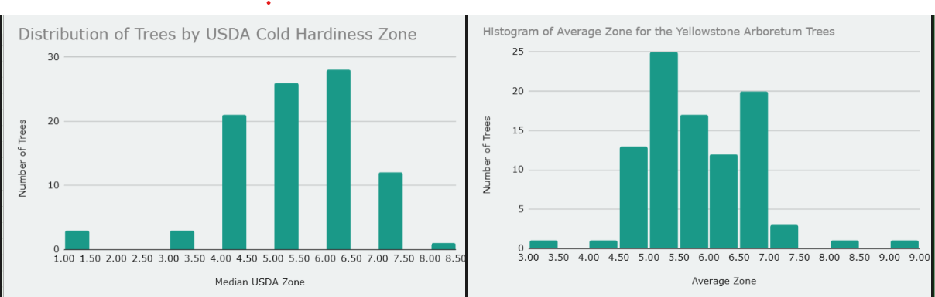
Figure One: Median USDA Zone Table & Figure Two: Average USDA Zone Table
Comparative analysis was used to look at the different climates specifically. The main areas that we are comparing include Japan, China, Korea, Russia, Central Asia, Europe, Canada, Mexico, and the Himalayas. The main climates in these areas are Humid Continental, Subarctic, and Temperate Continental. All of these fall into the three categories of dry temperate and continental. Comparing these climates with the Montana climate, which is dry and semi-arid as well as cold (Cui, Liang, & Wang, 2021). This means the soil is barren and lacks rain for most of the year. For other trees to do well in this climate by comparison, they would need to be hardy, drought-resistant, and be able to handle fluctuating temperatures (Cui, Liang, & Wang, 2021).
Results
Using the comparative analysis method involved breaking down the arboretum's trees by origin. While there are trees from all around the globe, there are none from South America, Africa, or Australia. The majority of the trees come from Asia and Europe, with 34 trees from China, 33 from Japan, 17 from Korea, and 31 species from Europe. It is important to note that there are multiple trees with a wide geographic range for their origin, and some trees could span multiple countries and regions. An example of this is the European Hornbeam, which, despite its name, can be found in the wild in Europe, Western Asia, and China. These locations reflect a wide concentration of climates, with the majority of them being temperate, with many of the asian trees being able to handle cold winters, as well as seasonal changes in weather. Europe also tends to have a similar weather pattern to Montana, as it goes through a wide range of temperatures throughout the year. The last area we see trees is in smaller groups in more outlier regions. These include Russia with 5, Mexico with 3, and Canada with 5 species. These areas do not have a similar climate to Montana, and the few trees in the Arboretum that are from these areas have a wider climate tolerability because these areas are either much colder or much warmer year-round than compared to Billings, Montana. With this information, it can be concluded that the Yellowstone Arboretum is able to handle trees with heat and cold tolerance. Trees found in similar climates that can handle the cold are the primary concern, while other concerns, like water levels, are less of an issue. This is because while looking at the Koppen climate, it's not a direct comparison. This study is comparing wild tree origins to an arboretum that is able to help with different issues, such as frost, watering, pests, wind protection, nutrition, and barren land, leaving the main issue being the weather changes within the climate. This becomes extremely clear through the use of the Koppen climate classification.
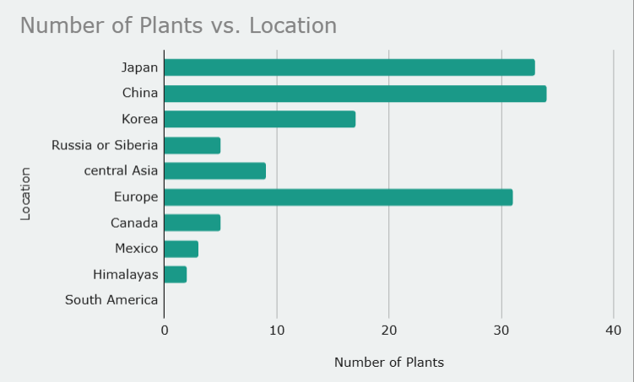
Figure 3: Origin Breakdown Table

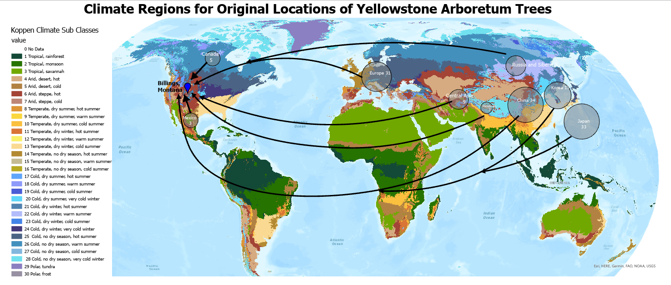
Figure 4: Koppen Climate Origin Map
The next set of results from the study specifically looks at the drought tolerance of the trees. It is crucial information as different climates, like Montana, are drier than others. While arboretums can help even out the differences, they then water trees that tend to be more drought-prone. Though it is necessary to figure out which trees are drought-prone to balance the amount of trees needing extra water with hardy trees, so as not to overload an arboretum. The trees within this study were categorized into three sections: drought-tolerant, moderately drought-tolerant, or prone to drought. With Montana being an arid climate, the majority of the trees would need to be moderately drought-tolerant or completely drought-tolerant to not be at risk of any health or watering issues. The data from the portfolio of trees reflects this notion as the majority of the trees fall into either moderately or completely drought-tolerant categories. With all 94 trees, 37.2 percent were moderately drought-tolerant, while 44.7 percent were completely tolerant. The remaining 18.1 percent were prone to drought. This shows that the Yellowstone Arboretum is able to water its trees but balances the workload by only having to water a few trees, or in times of extreme drought. However, this also opens the possibility for future trees that can not adapt to changes in watering to be taken in by arboretums that are able to manually water them.
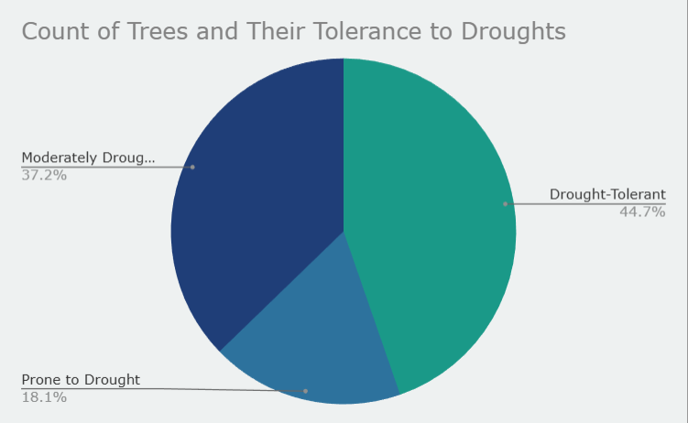
Figure 5: Pie Chart Breakdown of Drought Tolerance
The next result from the data is the breakdown of factors within the trees that could affect the arboretum's decision on whether they take on care for the tree within their collection. Similar to whether arboretums are willing to water a large amount of drought-prone trees. These factors can be broken into two main sections: positive factors and negative factors. The positive factors include endangered species planted for conservation, trees with aesthetic purposes, and trees planted for pollination. The negative factors include trees prone to diseases, invasive species, and of course, trees that die or become unhealthy due to not being able to handle the climate. The number of dead trees includes 42 trees planted for aesthetic purposes, 7 trees that are good at pollinating, and 15 trees that can become invasive. Then there are 5 trees that are endangered in the wild, 15 trees prone to disease, 9 dead specimens, and 1 unhealthy tree. Whether these trees fall into a certain category is not a complete deciding factor, but it can change how decisions are made about the trees. For example, the Yellowstone Arboretum has a collection of ash trees, including the international European mountain ash tree. These trees are no longer being propagated or purchased, as these trees are prone to the emerald ash borer, which is sweeping the country, and to mitigate future risk, they are cutting out new trees prone to the borer (Feilds, 2025). On the opposite end, however, the Ussurian pear was planted in the arboretum's Asia garden as a way to help pollinate the other pear trees in the area. It is important to note that with the pollinators and aesthetic-based trees, they can be intertwined; many trees can be pollinators. The trees in this study were categorized based on their main use, whether they are known to be used for pollination or decoration.
Finally, the example that relates closely to the risks of climate change is the endangered trees. There is a collection of spruce, including the Koyami Spruce, which is a prime example of conservation of trees within arboretums. The dead specimen, while seeming irrelevant, is an indication of which trees may not thrive within a different climate, such as Montana, or at the very least shows that they were unable to thrive in their planted location. While there are endangered species in their original habitat, they are being taken care of in arboretums like the Yellowstone Arboretum. This is the exact point this study is trying to achieve: that the trees in danger or at risk in their original habitats can be preserved through arboretums with similar climates, the way the Koyami Spruce has been preserved within the Yellowstone Arboretum.
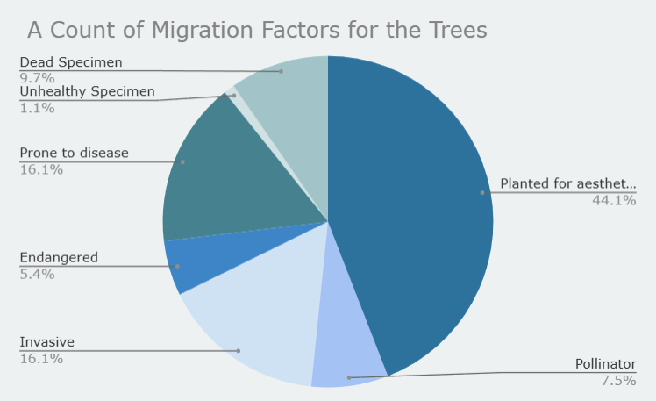
Figure 6: Breakdown of Trees and Their Transplanting Factors
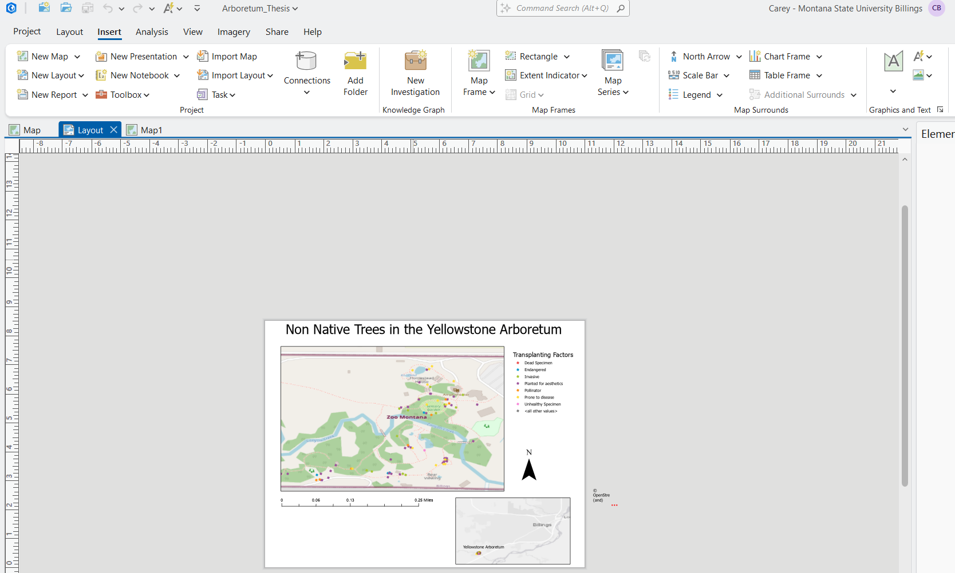
Figure 7: Map of Yellowstone Arboretum and its International Trees
Discussion
The findings within this study show the Yellowstone Arboretum's ability to take on and care for international trees, mitigating environmental stress and harboring trees as global climate temperatures change past a sustainable rate. While arboretums can not change the weather, they can account for other risk factors for trees, like drought or pest and disease control. The ultimate deciding factor of whether a tree can be moved is what the arboretum can handle when it comes to individual care, and if the climates are at all compatible. This study looks at this factor for the climate of Montana, and which regions can be compatible with the Yellowstone Arboretum. By comparing the different origins’ climate with the continental dry climate of Montana, we can see that this level of climate switching is possible among trees. These findings are incredibly important as they are not just comparing climates but compatibility, as the future changes the climates for all species. An example of the wonders that can be done with preservation is the Ginkgo trees, which the Yellowstone Arboretum has three of. These trees were thought to be extinct for an incredibly long time. In fact, when it was rediscovered, it was so unique that it had no related relatives; there is not a tree like it in the world (Smith, 2024). It had lived in the mountains of China, but monks had taken it to a palace and monasteries in Japan for its aesthetically pleasing properties(Smith, 2024). This is, of course, an extreme case, but a prime example of what arboretums and human intervention can help with.
This study, while efficient in drawing connections, does have some limatiations that can be worked on. The prime limitation was that most of the data collection was done in winter, when most trees do not produce any foliage or flowers. This means that while the majority of trees were alive and classified as healthy, there could have been other stress factors at play. These main factors are if the tree is unable to produce flowers or fruit or leaves in the summer time due to the winter stress. Despite the issues of the study, there are still meaningful connections between the ability of trees and their climate adaptability.
Conclusion
The Yellowstone Arboretum has been able to demonstrate its ability to take care of a vast collection of international trees. The study used USDA cold hardiness zones and Köppen climate classifications to compare the climates and see that individual trees with a wide range of climate hardiness, often seen as outliers, were able to thrive well in the arboretum. On the other hand, many trees with other constraining factors, like drought or pest-prone conditions, could be given individual care to increase their ability to thrive in a different climate. Factors such as choosing trees for aesthetic or pollination value can bring added benefits to the ecosystem of an arboretum. The dead specimen found within the study provides a lesson in future planning on whether the tree is capable of survival. While the endangered trees are an example of why climate compassion is important to look at, as it can help trees struggling due to human impact and climate change live without the possibility of extinction. Arboretums have many uses; they can be seen as a zoo for trees, used for research or aesthetic values, but at their core, the conservation of their collections takes priority. This means in an ever-changing world where many species are threatened due to the change in climate and loss of habitats, arboretums can become a haven for the trees and can preserve them for future generations to see.

Sources

ArcGIS. (n.d.-a). Map of Yellowstone Arboretum’s International Trees https://arcg.is/KWH5y
ArcGIS. (n.d.). https://www.arcgis.com/home/item.html?id=1e468410784c4b9a81f43af7f0f9b133
Barve, N., Ashraf, U., Barve, V., Cobos, M. E., Nuñez-Penichet, C., & Peterson, A. T. (2024). Revisiting plant hardiness zones to include multiple climatic stress dimensions. iScience, 27(10), 110824. https://doi.org/10.1016/j.isci.2024.110824
Berendsen, C. (n.d.). Treedata for thesis. Google Sheets. https://docs.google.com/spreadsheets/d/1SfnD53oj_xvd-A-XMs89K-w31fV5YgtL887hwIaiBZw/edit?usp=sharing
Crane, P. R. (2019). An evolutionary and cultural biography of ginkgo. Plants, People, Planet, 1(1), 32-37.
Cui, D., Liang, S., & Wang, D. (2021). Observed and projected changes in global climate zones based on Köppen climate classification. Wiley Interdisciplinary Reviews: Climate Change, 12(3), e701.
ESA Climate Office. (2025, June 2). Northern Hemisphere forests have shifted from carbon sinks to carbon emitters. Northern hemisphere forests have shifted from carbon sinks to carbon emitters. https://climate.esa.int/en/news-events/Forests-turn-from-carbon-sinks-to-emitters
Fields, A. (2025, June 17). Emerald Ash Borer. Rowan University’s Arboretum. https://arboretum.rowan.edu/learn/explore-insects/emerald-ash-borer/
F, Y. S., Ha, S. G., & Park, C. Y. (1970, January 1). Importance and specialization plan of the indicators by the function of the arboretum. Journal of Korean Forestry Society. https://agris.fao.org/search/en/providers/122646/records/6472525d53aa8c8963062381
Haimerl, K. (2025, September 22). Climate change puts pressure on plant diversity in African Mountains. Climate change puts pressure on plant diversity in African mountains. https://phys.org/news/2025-09-climate-pressure-diversity-african-mountains.html
Mann, A. (2025, May 6). Even common plants threatened by climate change, New Study Shows. Franklin College: where students find their path and pursue their passion. https://franklin.uga.edu/news/stories/2025/even-common-plants-threatened-climate-change-new-study-shows
Opgenhaffen, V. (2024, February 29). How do we save the world’s trees? The Morton Arboretum. https://mortonarb.org/blog/how-do-we-save-the-worlds-trees/
Primack, R. B., & Miller-Rushing, A. J. (2009, March 27). The role of botanical gardens in climate change research. New Phytologist. https://nph.onlinelibrary.wiley.com/doi/epdf/10.1111/j.1469-8137.1995.tb03067.x
Rehder, A. (1926). NEW SPECIES, VARIETIES AND COMBINATIONS FROM THE HERBARIUM AND THE COLLECTIONS OF THE ARNOLD ARBORETUM. Journal of the Arnold Arboretum, 7(1), 22–37. http://www.jstor.org/stable/43780416
Smith, B. H. (2024, October 24). The history of the Ginkgo Tree. Home & Garden Information Center. https://hgic.clemson.edu/the-history-of-the-ginkgo-tree/#:~:text=Thought%20to%20be%20extinct%2C%20a,sacred%20trees%20by%20Buddhist%20monks.
Solomon, A. M., & Kirilenko, A. P. (1997). Climate Change and Terrestrial Biomass: What if Trees do not Migrate? Global Ecology and Biogeography Letters, 6(2), 139–148. https://doi.org/10.2307/2997570
Weatherspark. Billings Climate, Weather By Month, Average Temperature (Montana, United States) - Weather Spark. (2025). https://weatherspark.com/y/3130/Average-Weather-in-Billings-Montana-United-States-Year-Round
U.S. Department of the Interior: National Park Service. (2022, December 22). Plants and climate change (U.S. National Park Service). Plants and Climate Change. https://www.nps.gov/articles/000/plants-climateimpact.htm
Watts, J. (2025, September 25). Big trees in Amazon more climate-resistant than previously believed. The Guardian. https://www.theguardian.com/environment/2025/sep/25/study-shows-big-trees-in-amazon-more-climate-resistant-than-previously-believed
Climate Change Alliance of Botanic Gardens. (2022). Climate Succession for ‘Climate Ready’ Botanic Gardens: A Landscape Succession Toolkit. Available from: https://www.rbg.vic.gov.au/media/tagodzaa/ccabglandscapesuccessiontoolkit.pdf

